Student Assessment Submission and Declaration
When submitting evidence for assessment, each student must sign a declaration confirming that the work is their own.
Student name: Adel Shurab / 21023153/NG95973 |  | Assessor name: Maisa Halloush
Issue date (1St Submission):  19/3/2023 | Submission date (1St Submission):  2/6/2023 |  | Submitted on:  1/6/2023
In case of resubmission
Issue date (1St Submission):  13/6/2023 | Submission date (1St Submission):  16/6/2023 |  | Submitted on:
Programme: HND in Computing - Software Engineering
HND in Computing - Cyber Security
HND in Computing - Intelligent Systems
HND in Cloud Computing - Cloud Software Development
Assignment number and title: 1- BI for business improvement and decision support

Task2:

Q1

Effective decision-making depends on the type of decision and the level of management involved. Therefore, decision support tools should be tailored to the specific needs of decision-makers to help them make informed choices.

Structured decisions are routine and follow established procedures. They are repetitive, and decision-makers do not need to exercise a lot of discretion or creativity. Examples of structured decisions include routine tasks like invoicing, payroll processing, and inventory management. To support structured decisions, decision support tools may involve streamlining procedures to make them more efficient.

Unstructured decisions, on the other hand, are complex and require subjective judgment, intuition, and creativity. They are ill-defined problems that do not have a clear set of procedures or rules to follow. Examples of unstructured decisions include strategic planning, crisis management, and new product development. To support unstructured decisions, decision support tools may involve providing access to high-quality information, sophisticated analysis and modeling capabilities, and expert systems.

Semi-structured decisions have some established procedures or rules, but also require subjective judgment and evaluation. They often involve budget planning, project management, and employee performance evaluations. To support semi-structured decisions, decision support tools may involve providing access to relevant information of routine tasks, analytical tools to aid in decision-making, and guidance on how to evaluate subjective factors.

The responsibilities and information requirements for decision-making vary depending on the level of management within an organization. Decision support tools should be customized to the decision type and the level of management involved to assist decision-makers in making informed decisions.

Senior Managers are responsible for making strategic decisions that significantly impact the organization. They frequently make unstructured decisions that necessitate judgment, evaluation, and insight. Decision support for senior managers may entail providing access to high-quality information, modeling and simulation tools, and expert systems that aid in decision-making.

Middle Managers are responsible for executing the decisions made by senior managers and making decisions that impact their department or team. They make more structured decisions, but these may still include unstructured components. Decision support for middle managers may involve providing access to relevant department or team information, analytical tools, and automated workflows that help in decision-making.

Operational Managers and Employees are responsible for making daily decisions that support the organization's objectives and goals. These decisions are usually structured and adhere to established procedures. Decision support for operational managers and employees may involve providing access to job function-specific information, automated workflows, and standardization of procedures to aid in decision-making.

Decision Support Tools are computer-based tools that assist decision-makers in analyzing information and making informed decisions. These tools should be tailored to the level of decision-making and the type of decision being made.

High-Level Support Tools are designed to assist senior managers in making unstructured decisions. These tools should be capable of managing large amounts of data and providing sophisticated analysis, modeling, and simulation capabilities. These tools should also be user-friendly and able to provide easily understandable results.

Q2-

The senior manager's decision in solving the huge number of questions on social media which need quick response may be to implement a social media listening and engagement strategy. This strategy would involve using business intelligence tools to monitor social media channels for mentions of the company and its products, and respond to customer inquiries and concerns in a timely and effective manner.

Business intelligence tools can enhance this decision by providing the following support:

Social Media Monitoring: Business intelligence tools can be used to monitor social media channels for mentions of the company and its products. This allows the senior manager to quickly identify and respond to customer inquiries and concerns.

`Sentiment Analysis: Business intelligence tools can be used to analyze social media posts and determine the sentiment behind them. This can help the senior manager to quickly identify potential issues and take appropriate action.

Performance Metrics: Business intelligence tools can be used to track performance metrics, such as response time and customer satisfaction, to ensure that the social media listening and engagement strategy is effective.

Historical Data: Business intelligence tools can provide access to historical data on social media interactions, allowing the senior manager to identify trends and patterns and make informed decisions about how to improve the social media listening and engagement strategy.

Q3-

Operational Level:

The operational level of management is responsible for making day-to-day decisions that ensure the efficient functioning of the company. This level of management includes front-line managers and employees who are responsible for the production, delivery, and support of products or services. Examples of operational level decisions include setting production schedules, managing inventory levels, and managing customer service requests.

Information systems and technologies that support operational level decision-making include:

Transaction Processing Systems (TPS): These systems record and process daily transactions and help to manage data related to the company's core business processes.

Enterprise Resource Planning (ERP) Systems: These systems provide an integrated view of the company's operations and allow for real-time data analysis and reporting.

Customer Relationship Management (CRM) Systems: These systems help to manage customer interactions and support customer service efforts.

Tactical Level:

The tactical level of management is responsible for making decisions that support the company's long-term goals and objectives. This level of management includes middle managers who are responsible for planning, budgeting, and implementing strategies that support the company's overall mission. Examples of tactical level decisions include launching a new product line, expanding into new markets, and implementing new marketing strategies.

Information systems and technologies that support tactical level decision-making include:

Business Intelligence (BI) Systems: These systems provide tools for data analysis and reporting to support decision-making based on trends and patterns in data.

Decision Support Systems (DSS): These systems provide analytical tools and models to support decision-making.

Supply Chain Management (SCM) Systems: These systems help to manage the flow of goods and services through the company's supply chain and can support decision-making related to sourcing and distribution.

Strategic Level:

The strategic level of management is responsible for making decisions that shape the company's overall direction and long-term goals. This level of management includes top-level executives who are responsible for setting the company's strategy and making decisions about mergers and acquisitions, major investments, and divestitures.

Information systems and technologies that support strategic level decision-making include:

Executive Information Systems (EIS): These systems provide high-level data analysis and reporting to support strategic decision-making.

Knowledge Management (KM) Systems: These systems help to manage the company's intellectual assets, including knowledge, skills, and expertise, and can support decision-making related to innovation and growth.

Customer Intelligence Systems: These systems provide information about customer behavior and preferences to support decision-making related to product development and marketing.
Task 3
Q1: Negotiate how implementing business intelligence tools within business processes in general and within trading sector in specific is very beneficial especially in decision-making.
business intelligence tools can be extremely beneficial for businesses in general and for the trading sector in particular, as it can significantly enhance decision-making processes by :
- Improved Data Analysis: Business intelligence tools can help to gather and analyze large amounts of data quickly and accurately, which can provide insights into customer behavior, sales trends, and market conditions. This analysis can help businesses to make better-informed decisions about inventory management, pricing, and marketing.
- Enhanced Reporting: With business intelligence tools, businesses can generate real-time reports on various aspects of their operations, including sales, inventory, and profitability. These reports can provide key performance indicators (KPIs) and metrics that allow business owners and managers to monitor performance and adjust strategies accordingly.
- Efficient Planning: Business intelligence tools can help businesses to plan more efficiently by providing insights into future trends and potential challenges. This can include forecasting sales, anticipating changes in consumer behavior, and predicting market shifts.
- Competitive Advantage: By utilizing business intelligence tools, businesses can gain a competitive advantage by being able to respond quickly to changes in the market and adapt their strategies accordingly.
- Better Decision Making: Ultimately, the key benefit of business intelligence tools is the ability to make better-informed decisions. By having access to accurate and timely data, businesses can make more informed decisions about pricing, inventory management, marketing, and other key aspects of their operations.
Q2: Manage online search to show two succeeded trading companies that implemented business intelligence tools and how it improved their work.
here are two examples of trading companies that have implemented business intelligence tools and how it has improved their work:
1-Goldman Sachs: Goldman Sachs is a global investment banking and securities firm that provides a wide range of financial services. The company has implemented business intelligence tools to help its traders monitor market trends and make informed decisions about buying and selling securities. The tools provide real-time data and analysis, including market trends, news, and social media sentiment, which helps traders make faster and more informed decisions. Goldman Sachs has reported that the use of business intelligence tools has led to increased efficiency, improved profitability, and better risk management.
2- Fidelity Investments: Fidelity Investments is a multinational financial services company that provides a wide range of investment and trading services. The company has implemented business intelligence tools to help its traders analyze market trends and make informed decisions about buying and selling securities. The tools provide real-time data and analysis, including market trends, news, and social media sentiment, which helps traders make faster and more informed decisions. Fidelity Investments has reported that the use of business intelligence tools has led to increased efficiency, improved customer satisfaction, and more accurate decision-making.
Q3:
Business Intelligence (BI) tools are becoming increasingly popular for analyzing social media data, as they allow businesses to extract valuable insights and make data-driven decisions. However, the use of these tools can raise legal and ethical concerns that must be taken into account.
Privacy is a major legal issue when utilizing BI tools to examine social media data. Users of social media have a reasonable expectation of privacy, and it may be unlawful to gather and utilize their data for analysis without their permission. Therefore, it's crucial to get social media users' permission before gathering and analyzing their data. In order to prevent the disclosure of personally identifying information, data should also be anonymized.
Data protection rules, which vary by nation and area, are another legal worry. For instance, the General Data Protection Regulation (GDPR) in the EU mandates that companies seek consent from customers and safeguard their personal information. To ensure that the data they gather is processed securely and isn't disclosed to other parties without the user's consent, businesses must take the necessary precautions.

When using BI tools to analyze social media data, intellectual property rights should also be taken into account. Businesses must abide by the terms and conditions set forth by social media platforms while using their data in order to protect the platform's intellectual property rights.
When using BI tools to examine social media data, ethical considerations must also be made. Businesses must make sure that their analysis of social media data is based on reliable and representative data and prevent prejudice or discrimination. Additionally, it's critical to use social media data sensibly and refrain from using it for bad intentions.

Q4: Business intelligence tools can be employed to collect and analyze customers' data while complying with the General Data Protection Regulation (GDPR) in the European Union. GDPR requires companies to obtain customers' consent for collecting and using their personal data, as well as ensuring their data is protected and used only for specific purposes.

To collect customers' data, businesses can use various sources such as social media, website analytics, and customer feedback. Business intelligence tools can help analyze this data to gain insights into customer behavior, preferences, and trends.

Companies must ensure that the data is stored securely and that only authorized personnel have access to it. They should also ensure that the data is anonymized or pseudonymized where possible, to protect the privacy of individuals.
Task 4
Q3-
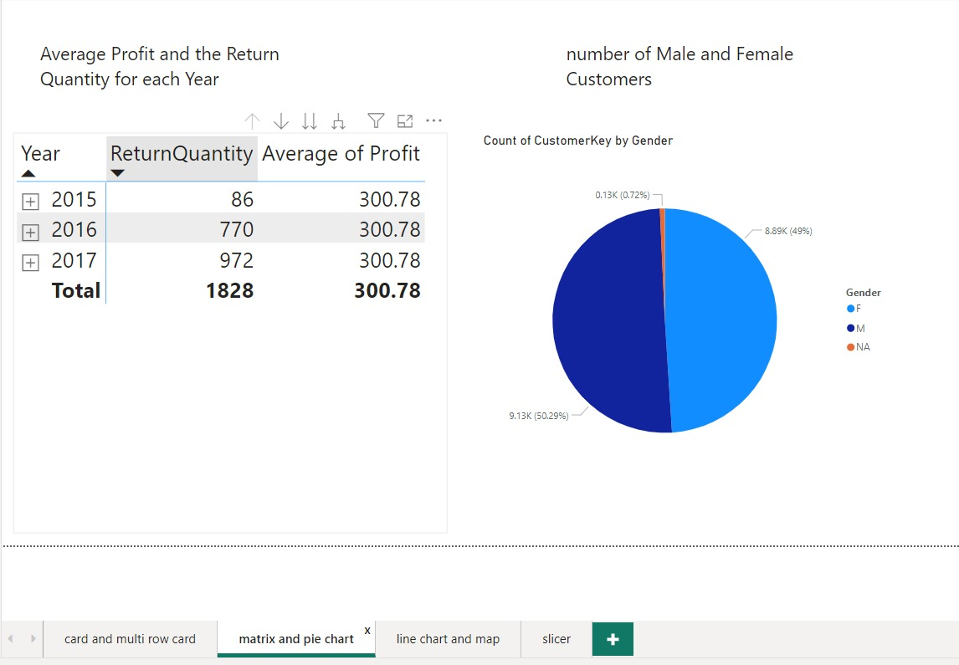
A-Here I made a table to show the annual sales and how much money was earned each year, and this makes it easier for the user to quickly know the sales each year.
B-pie chart: This shows the ratio of female and male employees
Q4-
A-
The dashboard I designed aims to meet business and user requirements by providing relevant, actionable information in an easy-to-use format
The dashboard is clear and understandable, as it explains the information in a visually comfortable way through tables, charts, and graphs, to allow the user to quickly understand. I also added titles for each page to make it easier for the user to have a title for each chart, table, and graph, and it explains everything in the work so that the user can understand it with ease.
The dashboard meets all the needs of the user and the user can see the update in real time to ensure that users have access to the latest information available to facilitate the user's decision-making in a timely manner and monitor the performance of users and respond to changes quickly.
B-
Business intelligence can have a significant impact on decision making when it comes to expanding sales territories to increase profits. Here are some of the ways business intelligence can influence this decision-making process:
Market analysis: Business intelligence can analyze the market in a detailed analysis, which allows business owners to know the demand for their products in the regions, and that is through the population segment in each region and the purchasing power, and also helps to know the markets that need their product to achieve profits.
Predictive analytics: Business savvy can predict profits and also predict sales success in new areas through data analysis and the use of algorithms. Through these algorithms, forecasting revenues and acquired customers, knowing potential risks, and helping business owners to make choices and estimate profits to enter a new market.

Q5-
Business intelligence (BI) is a term that describes the methods, tools, and techniques used to gather, examine, and meaningfully convey data to support business decision-making. It entails compiling data from many sources, turning it into insights that can be put to use, and presenting it in a way that empowers users to make wise decisions.

Microsoft's Power BI is a well-known business intelligence (BI) application that offers a number of features and capabilities for data analysis and the creation of interactive visualizations and reports. It allows data integration from various sources, including databases, spreadsheets, and web services, and provides a user-friendly interface. Users using Power BI may build interactive dashboards, do out ad hoc data analysis, and share their findings with others.
Tools used in BI :
- Python with tools like NumPy and Pandas: Python is a well-liked programming language for handling and analyzing data. In contrast to NumPy, which is a library for numerical computations, Pandas is a robust library that offers simple-to-use data structures and data analysis capabilities. They provide an extensive collection of operations for data processing, aggregation, cleaning, and statistical analysis when used collectively. Python is suitable for a variety of data analytics tasks due to its adaptability and robust library ecosystem. Python, coupled with Pandas and NumPy, can be used in a corporate setting to carry out complicated data analytics, create predictive models, automate time-consuming data activities, and draw valuable conclusions from huge datasets.
- Tableau: Tableau is a potent data visualization application that supports enterprises in the analysis and visual presentation of data. Users can link to many data sources, such as databases, spreadsheets, and cloud services, to acquire and combine data. Users can easily create interactive dashboards, charts, and graphs using Tableau's drag-and-drop interface, allowing them to effectively explore and express insights. Tableau can be helpful for tracking key performance indicators (KPIs), keeping track of sales and marketing metrics, spotting trends and patterns, and coming to informed conclusions in a business setting.

Reference:
Task 2
Q1 : Power, D. J. (2018). Decision Support Systems: Concepts and Resources for Managers. Business Expert Press.
Q2: Turban, E., Sharda, R., Aronson, J. E., & Liang, T. P. (2019). Decision Support and Business Intelligence Systems. Pearson.
Q3: Laudon, K. C., & Laudon, J. P. (2018). Management information systems: Managing the digital firm (15th ed.). Pearson Education.
Task 3
Q1: "10 Benefits of Business Intelligence Tools for Small and Medium-Sized Businesses." Tech.co, 12 May 2021, https://tech.co/news/benefits-of-business-intelligence-tools-2021-05.
Q2: "Business Intelligence at Goldman Sachs: Interview with Don Duet" by Bernard Marr, Forbes (2015): https://www.forbes.com/sites/bernardmarr/2015/08/31/business-intelligence-at-goldman-sachs-interview-with-don-duet/?sh=42f3a3c33b98
"Case Study: Fidelity Investments - Business Intelligence in Financial Services" by Prashant Thakur, Analytics Insight (2019): https://www.analyticsinsight.net/case-study-fidelity-investments-business-intelligence-in-financial-services/
Q3: Gartner. (2021). Legal and Ethical Considerations When Using Social Media Intelligence. Retrieved from https://www.gartner.com/en/marketing/research/legal-and-ethical-considerations-when-using-social-media-intelligence
Q4: European Union. (2018). General Data Protection Regulation (GDPR). Retrieved from https://eur-lex.europa.eu/eli/reg/2016/679/oj
Task 4
Selerity. (2021). The importance of predictive analytics in business intelligence. [online] Available at: https://seleritysas.com/blog/2021/08/14/the-importance-of-predictive-analytics-in-business-intelligence/.
Seto, F. (2022). Marketing Data Analytics for Business Decisions. [online] Coupler.io Blog. Available at: https://blog.coupler.io/marketing-data-analytics/.
Yellowfin BI. (2020). What are Dashboards? - BI and Analytics Tools | Types & Examples. [online] Available at: https://www.yellowfinbi.com/glossary/dashboards.
Stedman, C. (2020). What is Business Intelligence? BI Defined. [online] SearchBusinessAnalytics. Available at: https://www.techtarget.com/searchbusinessanalytics/definition/business-intelligence-BI.
Scardina, J. (2022). What is Microsoft Power BI? - Definition from WhatIs.com. [online] SearchContentManagement. Available at: https://www.techtarget.com/searchcontentmanagement/definition/Microsoft-Power-BI.
Intellipaat Blog. (2020). Top 6 BI - Business Intelligence Tools to Use in 2023. [online] Available at: https://intellipaat.com/blog/top-bi-tools/?US

Plagiarism
Plagiarism is a particular form of cheating. Plagiarism must be avoided at all costs and students who break the rules, however innocently, may be penalised. It is your responsibility to ensure that you understand correct referencing practices. As a university level student, you are expected to use appropriate references throughout and keep carefully detailed notes of all your sources of materials for material you have used in your work, including any material downloaded from the Internet. Please consult the relevant unit lecturer or your course tutor if you need any further advice.
Student Declaration
Student declaration
I certify that the assignment submission is entirely my own work and I fully understand the consequences of plagiarism. I understand that making a false declaration is a form of malpractice.

Student signature:ADEL SHURAB Date: 1/6/2023

